📜 Quiz Submission Log & Force Submission
View and force submissions still in attempt mode.

📌 Why Use Submission Logs & Force Submission?
✅ Verifies student activity – Check if students started on time.
✅ Detects potential technical issues – See if a student got logged out or had an incomplete submission.
✅ Prevents academic dishonesty – Identify patterns of multiple quiz restarts.
✅ Prevent Missing Grades - Unsubmitted quizzes remain incomplete, leading to gaps in grade records.
✅ Address Technical Issues - Students may encounter problems preventing them from submitting quizzes.
✅ Maintain Course Integrity - Ensures all assessments are accounted for and evaluated.

🛠 How to View Quiz Submission Logs
- Go to "Quizzes" → Click the dropdown next to a quiz.
- Select "Grade" to see all student attempts.
- Click on a student's quiz attempt to open the log.
- In the Quiz Attempt Summary, click "Quizzes Event Log".
- Review the details, including:
  - Start & Submission time.
  - Every question saved (time-stamped).
  - Any issues during the quiz
📌 Effect: Provides a full audit trail of student quiz activity, useful for resolving disputes or technical complaints.

🛠 Example Scenarios for Force Submission & Submission Logs
Scenario | Feature Used
Verify if a student started late. | Submission Log
Detect if a student stopped midway without submitting. | Submission Log
Check if a quiz was force-submitted due to time expiration. | Submission Log

🛠 How to Submit an In-Progress Quiz Attempt on Behalf of a Student
- Navigate to Quizzes:
  - From your course navbar, click on "Quizzes" under the Activities navbar.
- Access Quiz Grading:
  - Find the quiz in question, click the dropdown arrow next to its name, and select "Grade".
- Filter In-Progress Attempts:
  - Click "Show Search Options".
  - From the "Restrict to" dropdown, select "Users with attempts in progress".
  - Click the magnifying glass icon to search.
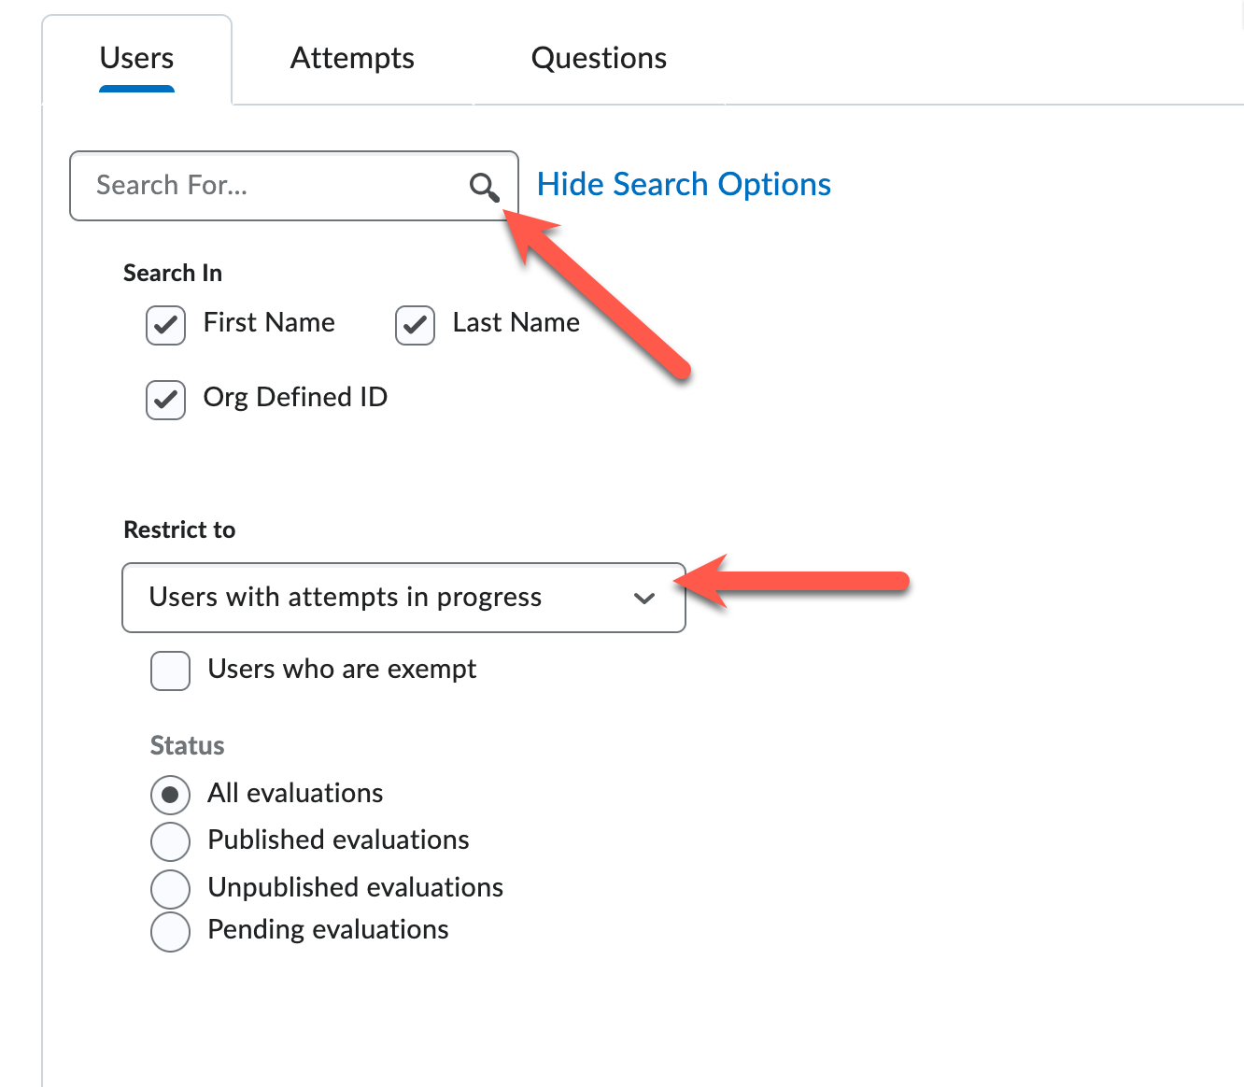
- Enter Quiz as User:
  - In the results, locate the student with the in-progress attempt.
  - Click the "Enter Quiz as User" icon next to their attempt.
  - Confirm by clicking "Yes" when prompted.
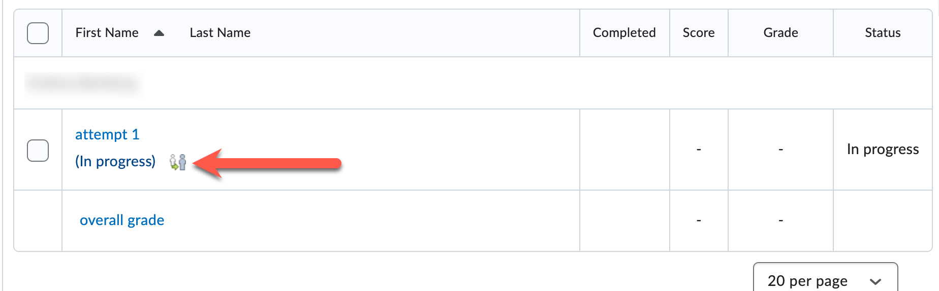
- Submit the Quiz:
  - Review the student's responses.
  - Scroll to the bottom and click "Submit Quiz".
  - On the confirmation page, click "Submit Quiz" again to finalize.
Note: This process ensures the student's attempt is recorded and graded appropriately.

💡 Additional Tips
- ✅ Regularly Monitor Quizzes: Periodically check for in-progress attempts, especially after quiz deadlines.
- ✅ Communicate with Students: Inform students about the importance of clicking "Submit" after completing quizzes.
- ✅ Provide Technical Support: Offer guidance for students facing issues during quizzes to minimize in-progress attempts.
- ✅ Enable "Auto-Submit" for Timed Quizzes – Prevent students from exceeding time limits.
✅ Review Submission Logs After Each Quiz – Ensure all students completed attempts correctly.
✅ Communicate Quiz Policies to Students – Let them know time limits are enforced.

